# Inner Classes

## Overview

In this lab, you will take some existing Swing GUI applications and refactor them to use inner classes.

## Source folders

Student project: StudentInnerClasses

Solution project: SolutionInnerClasses

## Roadmap

There are 3 exercises in this lab, of which the last exercise is "if time permits". Here is a brief summary of the tasks you will perform in each exercise; more detailed instructions follow later:

1. Defining an anonymous inner class
2. Defining several anonymous inner classes
3. Defining a regular inner class

## Exercise 1: Defining an anonymous inner class

In the student project, open SimpleSwingExample.java. This application uses the Swing API to create a simple window on the screen. Run the application to see what it looks like:

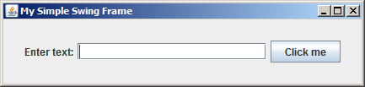

Enter some text in the text box, and then click the *Click me* button. A message box appears, confirming the text you entered:

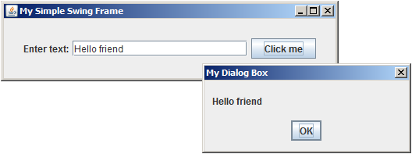

Now take a look at the code in SimpleSwingExample.java. It's not vital to understand all the details of Swing to complete this lab, but here are some observations to get you started:

* In Swing, a top-level window is represented by a JFrame object.
* You can add various components to a JFrame, such as a JLabel, a JTextBox, and a JButton in this example. (Technically speaking, you actually add these components to the *content* *panel* for the JFrame, which represents the client area inside the window).
* When the user clicks a JButton, an "action event" is generated. To handle this event:
  + Call the button's addActionListener() method, passing as a parameter an object of a class that implements the ActionListener interface. This interface has a single method named actionPerformed().
  + Implement the actionPerformed() method, to handle the button click.

Currently, the SimpleSwingExample class implements the ActionListener interface directly. This is not the best approach - typically, it is better to place event-handling logic in separate dedicated classes.

Therefore, refactor the SimpleSwingExample class so that it doesn't implement ActionListener directly. Instead define an anonymous inner class that implements ActionListener at the point where it's needed, to handle the button click. There are TODO comments in the code, indicating where you need to make your changes.

## Exercise 2: Defining several anonymous inner classes

In the student project, open DialogBoxExample.java. This application displays a main frame window that allows the user to display thee different types of dialog box:

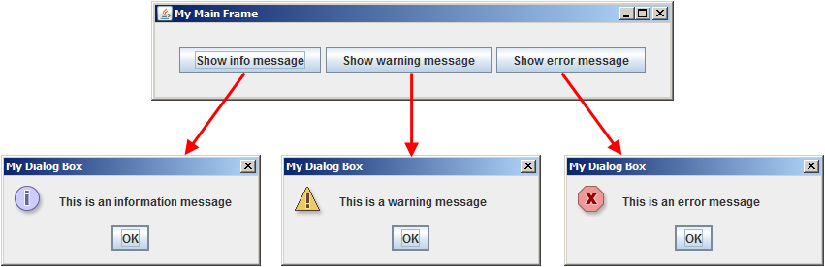

Take a look at the code in DialogBoxExample.java. The code is similar to the previous example, except that there are now 3 buttons to handle. Note the following salient details in the code:

* The DialogBoxExample class implements ActionListener itself. The class has a single actionPerformed() method, which will be invoked to handle button click events for all the buttons.
* The actionPerformed() method has to determine which button was actually clicked, so that it can decide what to do.

This situation is clearly unsatisfactory. It is undesirable to have a single implementation of ActionListener, because we have three buttons and each requires its own specific handler code.

Therefore, refactor the DialogBoxExample class so that it doesn't implement ActionListener directly. Instead define three anonymous inner classes, to handle each button click individually. There are TODO comments in the code, indicating where you need to make your changes.

## Exercise 3 (If time permits): Defining a regular inner classes

In the student project, open TableSortDemo.java. This application displays a frame that contains a JTable, which is a Swing data grid component:

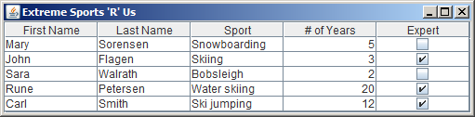

Note the following points in the application:

* If you click a column heading, it sorts the table on that column (it toggles between ascending/descending order).
* You can edit the last two columns.

Take a look at the code in TableSortDemo.java. Here's a brief summary of the important details (feel free to ask the instructor if you want to learn more about JTable in Swing):

* The TableSortDemo class extends JPanel. In other words, it's a custom panel that decides how to layout its constituent parts.
* The TableSortDemo constructor adds a JTable to the panel.
* The JTable object uses a MyTableModel object to define the data, column heading names, and other model-related information for the JTable.
* The MyTableModel class is currently defined as a top-level class (see the lower half of TableSortDemo.java).

Refactor the code, so that MyTableModel is defined as an inner/nested class within the DialogBoxExample class. You decide which mechanism to use.